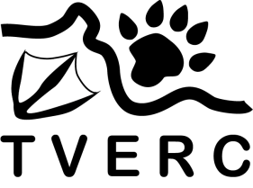
Thames Valley

Environmental Records Centre

Sharing environmental information in Berkshire and Oxfordshire

TVERC equipment and book loan request form

Please send completed forms to tverc@oxfordshire.gov.uk

Borrower’s name

Organisation or group

Address
Postcode

Email

Phone

Item requested | Quantity | Loan start date | Loan finish date

Expected date of records submission to TVERC

I agree to the terms and conditions of the loan, to pay a deposit and to pay any reimbursement costs for damage or loss or items within 14 days of the loan finish date.

Signed

For office use only
Loan authorised by

Date authorised

Pick up date

Time

Return date

