With Stuart Mabbutt from
Wildman Environmental Learning
Summer Nature and Horses Workshop
10.00 – 2.00 July 23rd
Summer Nature Activities, Picnic and Hugging Horses.
Learn Stress Management Techniques
for Work Through Mother Nature
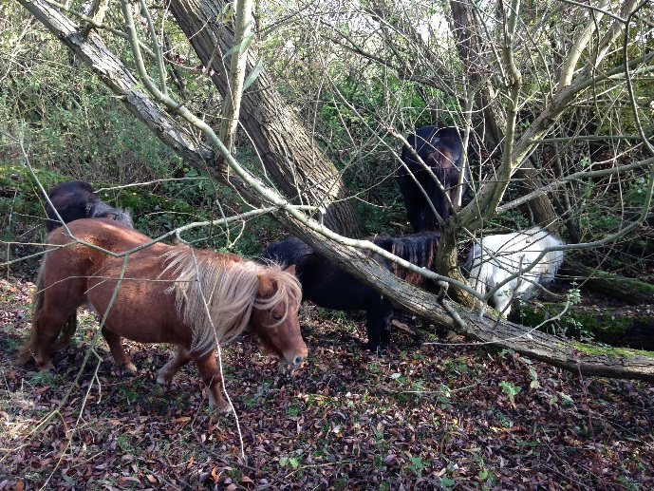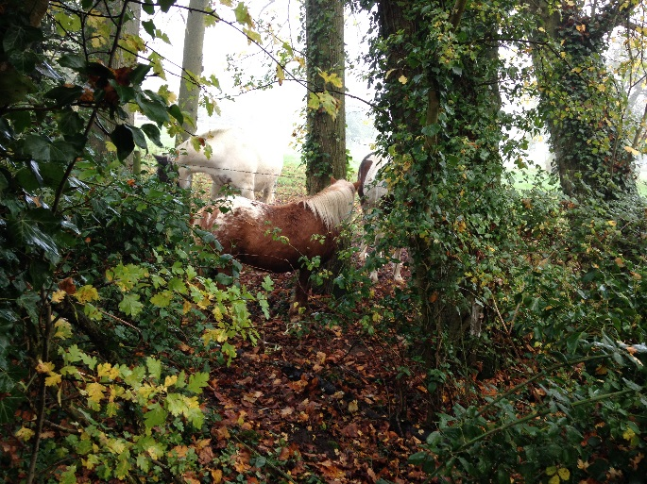
Cost £50 per adult children by donation
Pettiwell, Garsington, OX44 9DB
07780 675112
www.hopethruhorses.com
www.wildmaninspires.co.uk

